Coloplast Datafeed

User Documentation
Version 2.0


Contents
1 Document control 4
1.1 About this document 4
1.2 Changes made to this document 4
1.3 Purpose of this document 4
1.4 Audience for this document 4
2 Assumptions and constraints 5
3 Production Process 6
3.1 Prerequisites 6
3.2 Production Steps 7
3.3 Consolidated Dataview Generation Production Steps 14
4 Delivery Process 17
4.1 Delivery File 17
4.2 Delivery mail 17
5 Appendices 18
5.1 Change Request 18
5.2 Error during Production and Solution 18
References 20

Document control

About this document

Author | Rounok Faruque
Published
File location
Status | Released
Confidentiality | This document is confidential and must not be distributed outside of IMS Health.
Copyright | © 2026 IMS Health Incorporated or its affiliates. All rights reserved.

Changes made to this document

Version | Sections changed or created | Date of change | Author or contributor name | Role | Change summary
1.0 | All |  | Rounok Faruque |  | First release
2.0 | All Updated | 19-04-2011 | Rounok Faruque |  | Second release

Purpose of this document
The purpose of this document is to specify the procedure for delivering and bridging a consolidated Dataview databasefile to Coloplast.

Audience for this document
This document has been written for:
- OCD Team Members

Assumptions and constraints

ID | Assumptions
 | The Database Server is SQL Server 2008 R2.
 | Knowledge of IMS Dataview 7 is must.
 | Knowledge of Using the ALoad Tool.

ID | Constraint
 | Must use Excel 2007

Production Process

Prerequisites

Data Location
This is a Quarterly Production. 2 Input Dataviews will available at the following location in every 3 months. A confirmation mail on the data availability will come from Erik D’Hasseler
Host : ftp://ftp.lnd.gb.eu.rxcorp.com

User : ftpfalcon
Pass : flight01

German DB : /ftpfalcon/Coloplast/Germany Hospital
HMSAMCO-YYYY-MM-01.zip [MM = 03, 06, 09, 12]

International DB : /ftpfalcon/Coloplast/European
COLOPS_QqYY.ZIP [q=1, 2, 3, 4]

Alternate Location:
ftp://ftp-emea.rxcorp.com/Level2_OTCims/Client/
Database name: COLOPS_Q312.ZIP
Username: D08044
Password: CHProd

Production Server
Production Server : 10.223.200.28
User Name : INTERNAL\DACASVC-RDPAdmin
Password : Wh2t3v3r
Production Path : D:\CustomData\coloplast_datafeed

Database Server
Server Name : 10.223.200.28\MSSQLSERVER2008
DACSV0008\SQL2K8R2
Authentication : SQL Server Authentication
User Name : sa
Password : Pa$$w0rd
Database : COLOPLAST_DATAFEED

Production Steps

Backup Input, Output and Bridge Files

- Go to D:\CustomData\coloplast_datafeed\Data\Input\Hospital\Backup. Create a new folder named "YYYY MM" where MM = previous quarter month i.e. 03, 06, 09, 12 and backup previous input files (zip file, unzipped folder and the input text file i.e. Hospital_Qmm_yyyy.txt where mm = previous quarter month i.e. 03, 06, 09, 12) here.

- Go to D:\CustomData\coloplast_datafeed\Data\Input\International\Backup. Create a new folder named "YYYY MM" where MM = previous quarter month i.e. 03, 06, 09, 12 and backup previous input files (zip file, unzipped folder and input text file i.e. International_Qmm_2011.txt where mm = previous quarter month i.e. 03, 06, 09, 12) here.

- Go to D:\CustomData\coloplast_datafeed\Bridge File. Create a new folder named "YYYY MM" where MM = previous quarter month i.e. 03, 06, 09, 12 and backup previous bridge files (Coloplast_Bridge.xlsx, Coloplast_Bridge_Prev.xlsx and Coloplast_Bridge_Updated.xlsx) here.

- Go to D:\CustomData\coloplast_datafeed\Data\Output. Create a new folder named " YYYYQMM " where MM = previous quarter month i.e. 03, 06, 09, 12 and backup previous output file ConsolidatedOuput_QMM_YYYY.TXT

Download Input Files

- Download International DB COLOPS_QqYY.ZIP using FileZilla and put it in D:\CustomData\coloplast_datafeed\Data\Input\International.

- Download Hospital DB HMSAMCO-YYYY-MM-01.zip using FileZilla and put it in D:\CustomData\coloplast_datafeed\Data\Input\Hospital

Process Input and Bridge Files

- Unzip both input files to the corresponding location in a folder.
D:\CustomData\coloplast_datafeed\Data\Input\Hospital\HDKBCLP-YYYY-MM-01
D:\CustomData\coloplast_datafeed\Data\Input\International\COLOPS_QqYY

- Use PADDS Conversion Tools from D:\CustomData\coloplast_datafeed\Tools\Convert50\convert.exe

PROCESS International Data

- File – Analyze,
Source File Mask - Browse and select the .prm file from the location D:\CustomData\coloplast_datafeed\Data\Input \International\COLOPS_QqYY,
DB Type – Select Querterly,
Click on Scan Directory.
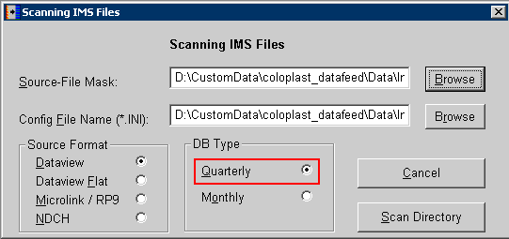

- Check Export Header

- Click Edit Hierarchies

- Remove all .DLL in the Snapin Section
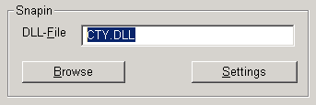

- Click OK, Then Click Convert – YES

PROCESS Hospital Data

- File – Analyze,
Source File Mask - Browse and select the .prm file from the location D:\CustomData\coloplast_datafeed\Data\Input\Hospital\HMSAMCO-YYYY-MM-01,
DB Type – Select Monthly,
Click on Scan Directory.
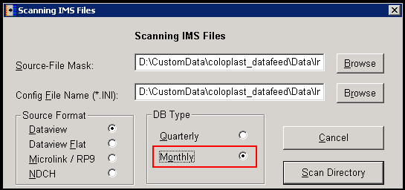

- Check Export Header

- Click Edit Hierarchies

- Delete CTY and PAN using the Delete button at the right side.
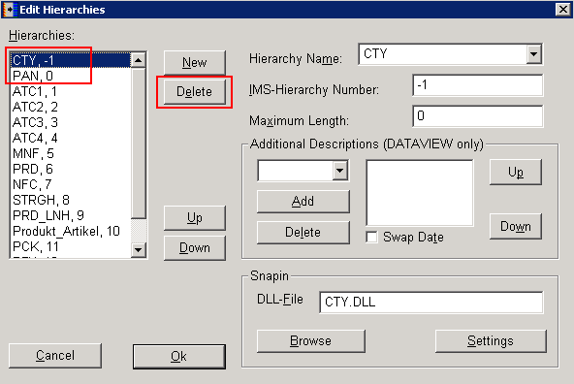

- Remove all .DLL in the Snapin Section
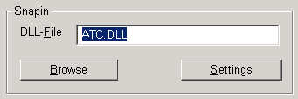

- Remove all entries from the Additional Descriptions using Delete Button
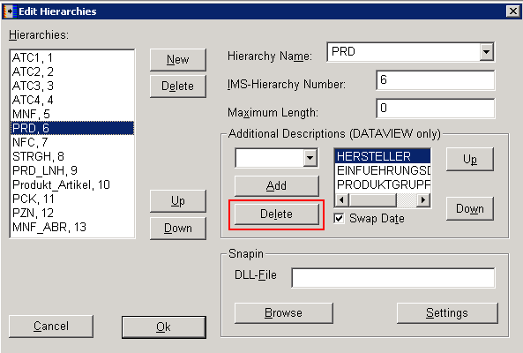

- Click OK

- Click on Edit Period
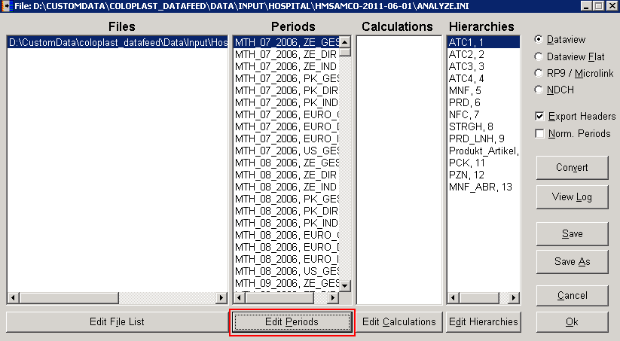

- Select the Fact measure ZE_DIR in periods at the left side and click on the Select Fact Button, this will select all the ZE_DIR measure Fact for all period
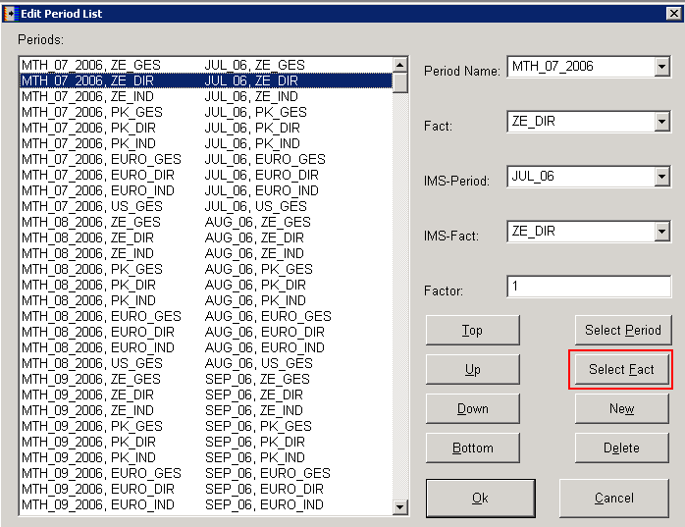

- Click on Delete Button to remove all the ZE_DIR Fact measure for all period
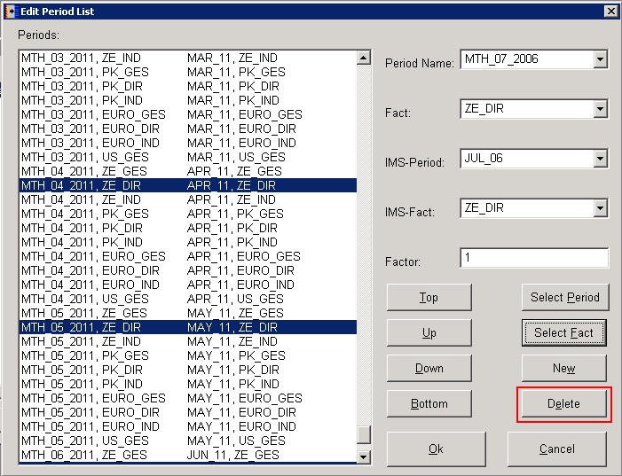
- Repeat the same process from 16 and 17 to delete the measure fact ZE_IND, PK_GES, PK_DIR, PK_IND, EURO_DIR and EURO_IND.

- Only 3 measure will be kept ZE_GES, EURO_GES and US_GES

- Click OK, Then Click Convert – YES

- Copy each input (.OUT) file and paste at the related location and rename accordingly with the extension .txt from .OUT
D:\CustomData\coloplast_datafeed\Data\Input\Hospital\Hospital_Mmm_YYYY.txt
D:\CustomData\coloplast_datafeed\Data\Input\International\International_Qqq_YYYY.txt
where mm = current production month and qq = current quarter month i.e. 03, 06, 09, 12

- Copy the latest updated bridge file Coloplast_Bridge_Updated.xlsx from the location D:\CustomData\coloplast_datafeed\Bridge File\YYYYMM and paste at the location D:\CustomData\coloplast_datafeed\Bridge File. Rename the file Coloplast_Bridge_Prev.xlsx

Production Process at SSIS Package

- Connect to the database COLOPLAST_DATAFEED from 10.223.200.28\SQL2KR2

- Now have to create new input table for both the Hospital and International Data. Follow step 3 to 6 to create new input tables.

- Right click on the latest International Input Table -> Script Table as -> Create to -> New Query editor Window.
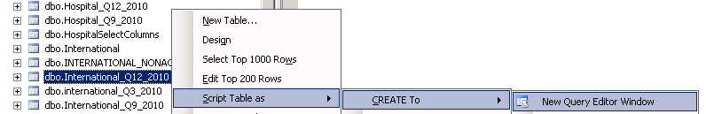
- Rename the Table Name with Current time period
Example :

International_Q12_2010 -> International_Q3_2011
International_Q9_2010 -> International_Q12_2010
International_Q6_2010 -> International_Q9_2010
International_Q3_2010 -> International_Q6_2010
International_Q12_2009 -> International_Q3_2010

- Modify the time Period – Cut the oldest time period and paste at the end.

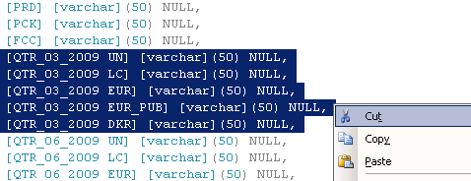

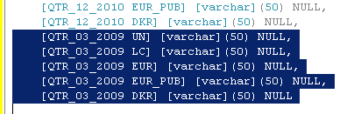

Update the time period name with latest input data year.

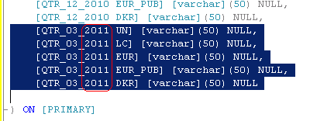

Execute this query which will create the new International Input Table.

- Follow the steps from 5 to 7 to create Hospital Monthly Input with the table Hospital_Mmm_2011 and Hospital Quarterly Input with the table Hospital_Qq_2011

- Open the SSIS Package from D:\CustomData\coloplast_datafeed\SSIS\Coloplast_New_dataLoad
\Coloplast_New_dataLoad.sln

- Open [01 Import.dtsx].

  - Click on “Load International Data”

  - Go to Data Flow Tab.

  - From Connection Managers Right Click on “Coloplast International Flat File” -> Edit. Browse and select the correct Input file. Following message will appear. Click Yes
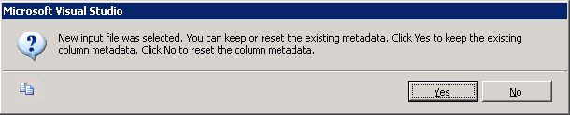
Click Column -> Reset Column -> OK.

  - Right Click on the Link (Green Colored) and Delete the Link.
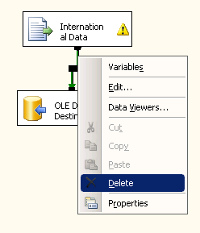
  - Select the OLEDB Destination and Delete.
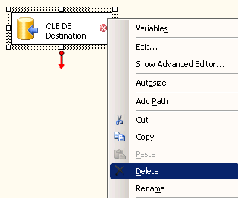
  - Right Click International Data -> Edit. The following message will appear. Click Yes
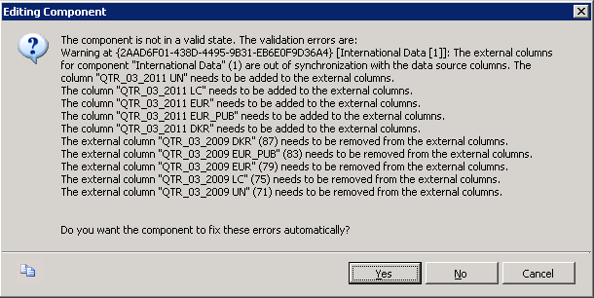
Then Click Columns -> Reset Column and take a look that the all the column including current period column is available or not. Click OK

  - From Toolbox at the left, Drag and Drop an OLEDB Destination.

  - Connect the link from International Data to OLEDB Destination.

  - Right Click on OLEDB Destination -> Edit.

  - Select the current International Input table
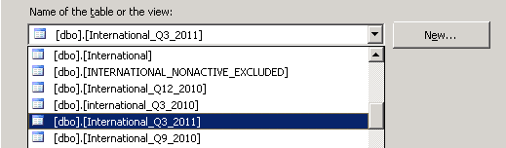

  - Click “Preview” to have a look whether all columns including current period column is available or not.

  - Click “Mapping” to have a look whether all the columns mapped with input columns. Then Click OK.

  - Follow the steps 8a) to 8k) for “Load Hospital Monthly Data”.

  - Right Click on “Process Period Table” -> Edit. Update the SQLStatement exec [SP_Process_Hospital_Period] 'Hospital_Mmm_YYYY'. where ‘Hospital_Mmm_YYYY’ = Current Hospital Monthly Table.

  - Right Click on “Generate Hospital QTR Data” -> Edit. Update the SQLStatement exec [SP_Generate_Hospital_Data] 'Hospital_Qq_YYYY', 'Hospital_Mmm_YYYY'. where 'Hospital_Qq_YYYY' = Current Hospital Quarter Table and ‘Hospital_Mmm_YYYY’ = Current Hospital Monthly Table

  - Right Click on “Remove Germany PAT Care” -> Edit. Update the SQLStatement delete from International_Qq_YYYY where CTY = 'GERMANY PAT CARE'. where 'International_Qq_YYYY' = Current International Quarter Table

- Save the package [01 Import.dtsx].

- Run the package [01 Import.dtsx]. This will load both International and Hospital current Quarter data in the respected Table.
International_Q3_2011.txt -> International_Q3_2011
Hospital_ Q3_2011.txt -> Hospital_ Q3_2011

- Open [02 Process Bridge.dtsx] which will generate Bridge files.
  - Create a Copy of Coloplast_Bridge_Prev.xlsx from D:\CustomData\coloplast_datafeed\Bridge File and paste at the same location. Rename the file Coloplast_Bridge.xlsx

  - Open Coloplast_Bridge.xlsx file and delete all the rows except the header. And if these files contain any other sheet then delete it as well. See the following reference file:
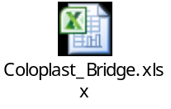

  - Right Click on 'Insert International Data' -> Edit. Click on the 'SQLStatement' -> Click on expand Button "..." and update the parameter of the query with latest International Input table name

  - Right Click on 'Insert Hospital Data' -> Edit. Click on the 'SQLStatement' -> Click on expand Button "..." and update the parameter of the query with latest hospital Input table name

  - Save the package [02 Process Bridge.dtsx]

  - Run the package [02 Process Bridge.dtsx]. This Package will generate new Coloplast_Bridge.xlsx. This Bridge file will generate with some new data which is currently present in the both Input file but not in the Bridge file.

  - Open the file Coloplast_Bridge.xlsx.

  - Mark the column color as below
Column A – Column J GREY
Column K – Column T GREEN
Column U – Column W YELLOW

  - Filter the Sheet. Select 1st Row -> Data -> Filter.

  - Check Number of CTY = 4 and below is the list of panels which is subscribed by client
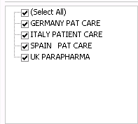
*This case is handled in the Package “Delete Unsubscribed CTY” step. But we need to check
this in the bridge file manually.

  - Check Column V, for NEW = ‘Y’, 3 column values will be updated.
CRP into CUST_CRP
MNF into CUST_MNF
INTPRD into CUST_INTPRD
*This case is handled in the Package “Update Bridge” step. But we need to check this in the
bridge file manually.

  - Save the File and File extension must be .xlsx

  - Check the file size with previous bridge file.

  - Rename the file name with Coloplast_Bridge_Qx_YYYY and zip the Coloplast_Bridge_Qx_YYYY.zip

  - Email the Bridge File to Erik D’Hasseler (EDHasseler@be.imshealth.com). Keep in CC the following persons
Rajibul Alam (RAlamJoarder@bd.imshealth.com)
IM Production & Support (Dhaka)
(LNDA-IMProdSupp@bd.imshealth.com)
Erik will send the bridge file to client for update. He will send us the updated bridge file through mail when he gets the file from client.
***************************************************
- When Erik send the updated bridge file keep it at the location D:\CustomData\coloplast_datafeed\Bridge File and rename the file Coloplast_Bridge_Updated.xlsx

- Open [03 Export.dtsx].

- Right Click on ' Extract Hospital Data ' -> Edit. Click on the 'SQLStatement' -> Click on expand Button "..." and update the parameter of the query with latest Hospital Input table name. Make Sure "dbo." will not included with the table name.

- Right Click on ' Extract International Data ' -> Edit. Click on the 'SQLStatement' -> Click on expand Button "..." and update the parameter of the query with latest International Input table name. Make Sure "dbo." will not included with the table name.

- Disbale the "Data Flow Task".[baki gulo enable kore diye run korte hobe.]

- Run [03 Export.dtsx].

- Open the txt file ConsolidatedOuput.TXT with Textpad from D:\CustomData\coloplast_datafeed\Data\Output

[ConsolidatedOuput.TXT file ta kei change korte hobe. And thn create hoyar pore i file ta k copy kore rename korte hobe. Tahole next time ei file name e file thakbe.]
- Cut the oldest Time period from the header and paste at the last of the header and update the Year. For example, for generating QTR/12/2011 data, oldest time period is

^QTR_12_2009 DKR^QTR_12_2009 EUR^QTR_12_2009 LC^QTR_12_2009 UN^QTR_12_2009 USD

Which should be

^QTR_12_2011 DKR^QTR_12_2011 EUR^QTR_12_2011 LC^QTR_12_2011 UN^QTR_12_2011 USD

Save and close the file ConsolidatedOuput.TXT

- Now Disable all the task and enable only "Data Flow Task".
- Select the "Data Flow Task" and click on the tab Data Flow.
- Right Click on the Consolidated Output from Connection manager , then Click Edit
- Click on Columns on the left panel, then Click on Reset Columns button. then OK.
- Right Click on OLE DB Source, click Edit and then click Yes. then Click ok.
- Right Click on Flat File Destination, Click Edit, Select "Delete Invalid Column Reference" from Column Mapping option at the bottom. Click Apply, then OK
- Right Click on Flat File Destination, Click Edit, Click Mapping, Go to bottom of the Input Column and Map the <ignore> Input column with the Output
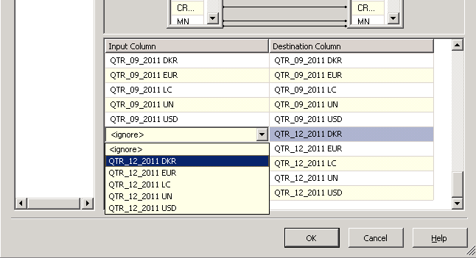

- Click ok and Save the package.
[table change hole mapping tik na korle error dite pare, and tokhon ei mapping tik kore thn package catale hobe.]

- Run the Package. This will create ConsolidatedOutput text file at the location D:\CustomData\coloplast_datafeed\Data\Output having name ConsolidatedOuput.TXT.

- Rename the output file with current Quarter Month and Year. ConsolidatedOuput_Qqq_YYYY.TXT

Consolidated Dataview Generation Production Steps

Backup Output Files

- Go to D:\CustomData\coloplast_datafeed\Tools\Aload\Backup. Create a new folder named "dataview_Qmm_yyyy" where mm = previous quarter month i.e. 03, 06, 09, 12

- Backup previous 7 dataview files, 1 output text file (ConsolidatedOuput.TXT), 1 Output Zip file there. [cut kore nite hobe ei file gulo]

- Copy the COLO.DDL file at the location D:\CustomData\coloplast_datafeed\Tools\Aload\Backup
\dataview_Qmm_yyyy.

Input File Location

- Copy the output file ConsolidatedOuput_Qmm_yyyy.TXT from D:\CustomData\coloplast_datafeed\Data\Output and paste at D:\CustomData\coloplast_datafeed\Tools\Aload

- Rename the file ConsolidatedOuput.TXT

Process for Generating Consolidated Dataview

- Open COLO.DDL file from D:\CustomData\coloplast_datafeed\Tools\Aload through Textpad to edit.
- Cut the oldest quarter period
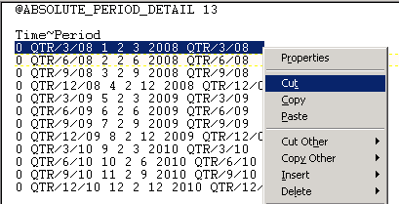

- Paste at the end and update the time period.
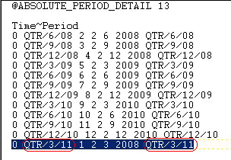

- Update the latest Year at the 6th Column last Row
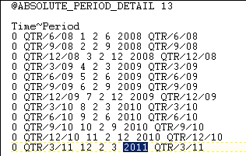

- Update 3rd Column like 1,2,3 … 10,11,12
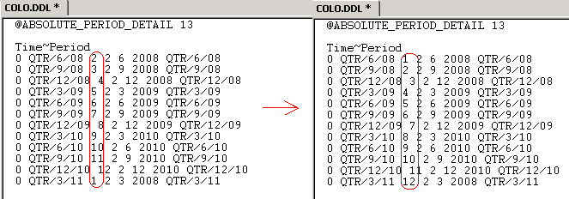
- Save the COLO.DDL File and Close

- Open Aload.exe from D:\CustomData\coloplast_datafeed\Tools\Aload

  - Click [Add Files] to add the file [COLO.ADP] from D:\CustomData\coloplast_datafeed\Tools\Aload

  - Change Delimiter from “,” to “^” and Lines "0" to "1"

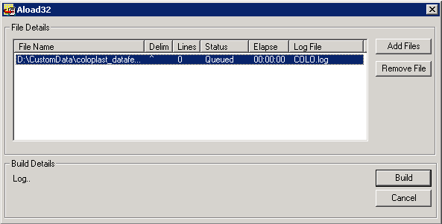

  - Click Build to build the Dataview Files.

  - After Successful Run, 7 Dataview Files will be created at the location D:\CustomData\coloplast_datafeed\Tools\Aload. The 7 files that will be create are COLO.BIT, COLO.COD, COLO.DAT, COLO.HDR, COLO.IND, COLO.NAM and DBCOLO.PRM.

- Zip 7 dataview files and name the zip file COLOPLAST_Qmm_yyyy.zip.
[QC er jonno .prm file current and previous ta check korte hobe, CTY, measure, time period niye. And Jodi kono new product add hoy thn CTY nite PROD query kore time period and measure nite hobe.]

Generic Failover process

For any kind of fail, please contact, Mainul Hassan (MHassan@bd.imshealth.com) and Rajib (RAlamJoarder@bd.imshealth.com) for further assistance.

Delivery Process

Delivery File

Consolidated Dataview Delivery

Delivery File Name: COLOPLAST_Qmm_yyyy.zip
File Location: D:\CustomData\coloplast_datafeed\Tools\Aload

Delivery mail

Consolidated Dataview Delivery mail
Attach COLOPLAST_Qmm_yyyy.zip and mail to

Erik D’Hasseler (EDHasseler@be.imshealth.com)
Keep in CC the following persons
Ajith Nair (ANair@uk.imshealth.com)
Noor A Kadir (nkadir@bd.imshealth.com)
Rajibul Alam (RAlamJoarder@bd.imshealth.com)
IM Production & Support (Dhaka)
(LNDA-IMProdSupp@bd.imshealth.com)

Appendices

Change Request
Date | Change Request | Solution
25-03-2011 | Add Country Panel “UK Pharma” | - Open Coloplast_New_dataLoad.sln from D:\CustomData\coloplast_datafeed  \SSIS\Coloplast_New_dataLoad  - Open 02 Process Bridge.dtsx  - Edit “Delete Unsubscribed CTY” and update the query. Add “UK Pharma” in the where clause  delete from dbo.masterDB_bridge  where CTY not in  (  'German Hospital Data',  'GERMANY PAT CARE',  'ITALY PATIENT CARE',  'SPAIN PAT CARE',  ‘UK Pharma’  )

Error during Production and Solution
Date | Error | Reason | Solution

References
The table below lists other materials that are relevant to this document.
Title | Author | Version | Date | Location

